## Scenario 2

In Fig. 5-49, the relationship between the energy loss probabilities of the network and each node and the HP packet arrival rate $λ_{H-arr}$ is depicted. It is observed that both $P_{el}$- $1$ and $P_{el}$- $2$ remain zero as $λ_{H-arr}$ increases. This relationship is due to the fact that the energy harvesting at nodes 1 and 2 is consistently insufficient to meet the service requirements of the packets in their respective queues ($ϕ_{req-n}>β_{n}$, *n*=1, 2). Consequently, whenever an energy unit arrives, it is immediately consumed by the packets waiting in the queues, resulting in no energy losses. In addition, for node 3, it is evident that as $λ_{H-arr}$ increases, $P_{el}$- $3$ only decreases slightly and then remains nearly constant. This behavior is due to the lower routing probability to node 3 compared to other nodes. As a result, the traffic at node 3 is relatively small, allowing the harvested energy to not only satisfy most of the arrived packets but even have an excess of energy available ($ϕ_{req-3}<β_{3}$). Furthermore, considering that each of the three nodes has the same energy arrival rate, $P_{el}$- $Ave$ can be calculated as the average of $P_{el}$- $1$, $P_{el}$- $2$, and $P_{el}$- $3$. Lastly, the analytical results are in good agreement with the simulation results.

In Fig. 5-50, the relationship between the blocking probabilities for all arrived packets of the network and each node and the HP packet arrival rate $λ_{H-arr}$ is depicted. It is observed that both $P_{bl}$- $Ave$ and $P_{bl}$- $1$ rapidly increase as $λ_{H-arr}$ increases. This relationship is due to the fact that higher values of $λ_{H-arr}$ result in a greater likelihood of the packet queue at node 1 becoming full, leading to an increased blocking probability for incoming packets. In addition, the curve of $P_{bl}$- $2$ exhibits an initial increase followed by a slight decrease. This behavior is a result of the congestion at node 1 caused by the increased arrival rate of external packets. As $λ_{H-arr}$ increases, fewer packets are able to enter node 2 per unit time due to the congestion, resulting in a slight reduction in the chance of being blocked. Consequently, due to the lower routing probability to node 3 compared to other nodes, the traffic at node 3 is significantly smaller. As a result, most of the arrived packets can be served immediately without waiting in the queue, leading to a blocking probability of zero ($P_{bl}$- $3=0$) for node 3. Furthermore, for the same value of $λ_{H-arr}$, it is observed that $P_{bl}$- $1$ is higher than $P_{bl}$- $2$, while $P_{bl}$- $3$ is the lowest. This pattern arises because node 1, being the entry node, receives the highest number of arrived packets. Node 2 experiences a relatively high packet arrival rate due to congestion at node 1, resulting in a slightly lower blocking probability than node 1. Node 3 has the lowest packet arrival rate due to smaller routing probabilities ( and ), leading to the lowest blocking probability among the three nodes. Lastly, the analytical results are in good agreement with the simulation results.

In Fig. 5-51, the relationship between the blocking probabilities for arrived HP and LP packets of the network and each node and the HP packet arrival rate $λ_{H-arr}$ is depicted. It is observed that the $P_{bl_H}$ and $P_{bl_L}$ are the same for each node. This is because once the packet queue at a node becomes full, any arrived packet, regardless of its priority, will be blocked. Additionally, it is evident that as $λ_{H-arr}$ increases, more packets enter the network, which increases the likelihood of the packet queues becoming full. Consequently, both $P_{bl_H}$ and $P_{bl_L}$ for node 1 and the entire network will significantly grow with increasing $λ_{H-arr}$. Consequently, the curves of $P_{bl_H}$- $2$ and $P_{bl_L}$- $2$ exhibit an initial increase followed by a slight decrease. This behavior can be attributed to the congestion at node 1. As $λ_{H-arr}$ increases, node 1 becomes more congested, resulting in a reduced number of packets entering node 2 per unit time. As a result, the chance of being blocked at node 2 is slightly decreased. In addition, due to the lower routing probability to node 3 compared to other nodes, the traffic at node 3 is significantly smaller. Consequently, most of the arrived HP and LP packets can be served immediately without waiting in the queue, resulting in $P_{bl_H}$- $3$ and $P_{bl_L}$- $3$ remaining at zero. Furthermore, for the same value of $λ_{H-arr}$, it is observed that $P_{bl_H}$- $1$ ($P_{bl_L}$- $1$) is higher than $P_{bl_H}$- $2$ ($P_{bl_L}$- $2$), while $P_{bl_H}$- $3$ ($P_{bl_L}$-3) is the lowest. This pattern arises because node 1, being the entry node, receives the highest number of arrived packets. Node 2 experiences a relatively high packet arrival rate due to congestion at node 1, resulting in a slightly lower blocking probability than node 1. Node 3 has the lowest packet arrival rate due to smaller routing probabilities ( and ), leading to the lowest blocking probability among the three nodes. Lastly, the analytical results are in good agreement with the simulation results.

In Fig. 5-52, the relationship between the total loss probabilities for all arrived packets of the network and each node and the HP packet arrival rate $λ_{H-arr}$ is depicted. It is observed that $P_{tl}$- $Ave$, $P_{tl}$- $1$ and $P_{tl}$- $2$ increase as the $λ_{H-arr}$ increases. This can be attributed to two main factors. Firstly, as the $λ_{H-arr}$ increases, the queues at each node are more likely to become full, resulting in a higher number of blocked packets. Secondly, as the packet queues become congested, the chances of losing packets due to impatience also increase. Additionally, it is evident that the curve of $P_{tl}$- $2$ initially increases and then remains constant. This behavior occurs because when the total external packet arrival rate surpasses the effective service rate of node 1, the packet arrival rate at node 2 is affected by the departure rate of node 1 and approaches a limit. Consequently, due to the lower routing probability to node 3 compared to the other nodes, the traffic at node 3 is significantly smaller. Consequently, $P_{tl}$- $3$ remains very low and does not change significantly as $λ_{H-arr}$ increases. In addition, it is observed that for the same value of $λ_{H-arr}$, $P_{tl}$- $1$ is higher than $P_{tl}$- $2$, while $P_{tl}$- $3$ is the lowest. This pattern arises because node 1, being the entry node, receives the highest number of arrived packets. Node 2 experiences a relatively high packet arrival rate due to blocking and impatience at node 1, resulting in a slightly lower total loss probability than node 1. Node 3 has the lowest packet arrival rate due to smaller routing probabilities ( $r_{13}$ and $r_{23}$), leading to the lowest total loss probability among the three nodes. Furthermore, it is important to note that for the entire network and each node, $P_{tl}$ is the sum of $P_{bl}$ and $P_{imp(arr)}$. Lastly, the analytical results are in good agreement with the simulation results.

In Fig. 5-53, the relationship between the total loss probabilities for arrived HP and LP packets of the network and each node and the HP packet arrival rate $λ_{H-arr}$ is depicted. It is observed that for the entire network and each node, the $P_{tl_H}$ and $P_{tl_L}$ increase as the $λ_{H-arr}$ increases. This relationship arises because a higher $λ_{H-arr}$ leads to more packets entering the network and nodes. Consequently, the packet queues fill up more quickly, and the waiting time for packets increases, making them more prone to impatience and subsequent loss. Additionally, it is evident that the curves of $P_{tl_H}$ are lower than those of $P_{tl_L}$. This discrepancy occurs due to the non-preemptive priority policy. As a result, HP packets have a higher probability of being served promptly, while most LP packets experience backlog and longer waiting times in the queue, increasing their total loss probabilities. In addition, due to the lower routing probability to node 3 compared to the other nodes, the traffic at node 3 is significantly smaller. Consequently, both $P_{tl_H}$- $3$ and $P_{tl_L}$- $3$ remain very low and do not change significantly as $λ_{H-arr}$ increases. Furthermore, for the same value of $λ_{H-arr}$, it is observed that $P_{tl_H}$- $1$ ($P_{tl_L}$- $1$) is higher than $P_{tl_H}$- $2$ ($P_{tl_L}$- $2$), while $P_{tl_H}$- $3$ ($P_{tl_L}$- $3$) is the lowest. This pattern arises because node 1, being the entry node, receives the highest number of arrived packets, resulting in a higher total loss probability for both HP and LP packets. Node 2 experiences a slightly lower total loss probability than node 1 due to blocking and impatience at node 1. Node 3, with the lowest packet arrival rate due to smaller routing probabilities ( $r_{13}$ and $r_{23}$), exhibits the lowest total loss probability among the three nodes for both HP and LP packets. Lastly, the analytical results are in good agreement with the simulation results.

In Fig. 5-54, the relationship between the impatient loss probability for all arrived packets of the network and each node and the HP packet arrival rate $λ_{H-arr}$ is depicted. It is observed that for the entire network and node 1, $P_{imp(arr)}$- $Ave$ and $P_{imp(arr)}$- $1$ exhibit a pattern where the curves initially rise and then fall as the $λ_{H-arr}$ increases. Initially, with sufficient energy, most packets can enter the network and node 1, leading to an increase in the number of impatient packets in the queue. However, as $λ_{H-arr}$ continues to increase and the energy supply becomes insufficient, the packet queue becomes congested, resulting in a significant number of packets being blocked from entering the network. As a result, the probability of impatience for arrived packets gradually decreases. Additionally, it is evident that the curve of $P_{imp(arr)}$- $2$ steadily increases as $λ_{H-arr}$ increases. This behavior arises because node 2 has a lower packet arrival rate compared to node 1. As a result, a larger proportion of arrived packets at node 2 are less likely to be blocked and can enter the queue, waiting for service. In addition, due to the lower routing probability to node 3 compared to the other nodes, the traffic at node 3 is significantly smaller. Therefore, $P_{imp(arr)}$- $3$ does not show a significant change as $λ_{H-arr}$ increases since most of the arrived packets at node 3 can be served immediately without waiting in the queue. Lastly, the analytical results are in good agreement with the simulation results.

In Fig. 5-55, the relationship between the impatient loss probabilities for arrived HP and LP packets of the network and each node and the HP packet arrival rate $λ_{H-arr}$ is depicted. It is observed that for the $P_{imp\left(arr\right)_L}$, $P_{imp\left(arr\right)_L}$- $Ave$, $P_{imp\left(arr\right)_L}$- $1$, and $P_{imp\left(arr\right)_L}$- $2$ all show an increasing trend with the increase of the increase. This behavior arises because as $λ_{H-arr}$ increases, more HP packets are able to enter the network, node 1, and node 2. Consequently, LP packets that are backlogged in the queue have to wait longer, increasing their likelihood of becoming impatient. Additionally, it is evident that for the $P_{imp\left(arr\right)_H}$, $P_{imp\left(arr\right)_H}$- $Ave$ and $P_{imp\left(arr\right)_H}$- $1$ initially increase and then decrease, while $P_{imp\left(arr\right)_H}$- $2$ continues to increase. This behavior is attributed to the congestion in the packet queue of node 1. As $λ_{H-arr}$ increases, the packet queue becomes overwhelmed, resulting in a significant number of packets being blocked. Therefore, the probability of impatience for arrived HP packets gradually decreases. However, at node 2, which has a lower packet arrival rate than node 1, most of the arrived HP packets are less likely to be blocked and can enter the queue for service, leading to a continued increase in the probability of impatience for arrived HP packets. In addition, due to the lower routing probability to node 3 and its smaller traffic compared to the other nodes, the $P_{imp\left(arr\right)_H}$- $3$ and $P_{imp\left(arr\right)_L}$- $3$ remain very low and do not significantly change as $λ_{H-arr}$ increases. This is because most of the arrived packets at node 3 can be served immediately without waiting in the queue. For node 1, node 2, and the entire network, we can observe that the curves of $P_{imp\left(arr\right)_H}$ are significantly lower compared to $P_{imp\left(arr\right)_L}$. This is because the non-preemptive priority policy favors the servicing of HP packets. In contrast, LP packets tend to experience backlogging in the queue, resulting in a higher probability of impatience and loss. Lastly, the analytical results are in reasonable agreement with the simulation results.

In Fig. 5-56, the relationship between the impatient loss probabilities for all admitted packets of the network and each node and the HP packet arrival rate $λ_{H-arr}$ is depicted. It is observed that both $P_{imp(adm)}$- $Ave$ and $P_{imp(adm)}$- $n$, *n*=1, 2, 3, increase as $λ_{H-arr}$ increases. This trend is due to the higher influx of packets into the network and each node, leading to increased waiting times in the queues and a greater likelihood of packets becoming impatient and being lost. Additionally, it is evident that when comparing the nodes for the same $λ_{H-arr}$, $P_{imp(adm)}$- $1$ is higher than $P_{imp(adm)}$- $2$, while $P_{imp(adm)}$- $3$ is the lowest. This discrepancy is primarily attributed to node 1 receiving the most packet arrivals as the entry point, node 2 experiencing higher packet arrivals due to potential blocking and impatience at node 1, and node 3 having the lowest packet arrival rate due to smaller routing probabilities ( $r_{13}$ and $r_{23}$). Lastly, the analytical results are in good agreement with the simulation results.

In Fig. 5-57, the relationship between the impatient loss probabilities for admitted HP and LP packets of the network and each node and the HP packet arrival rate $λ_{H-arr}$ is depicted. It is observed that both $P_{imp\left(adm\right)_H}$ and $P_{imp\left(adm\right)_L}$ increase as $λ_{H-arr}$ increases. This relationship is due to the fact that the higher influx of packets into the network and nodes, leading to longer queue waiting times and an elevated risk of impatience. Additionally, it is evident that the curves of $P_{imp\left(adm\right)_H}$ are significantly lower than those of $P_{imp\left(adm\right)_L}$ for the entire network, node 1, and node 2. This discrepancy stems from the non-preemptive priority policy, favoring the service of HP packets, while LP packets tend to accumulate and experience backlog in the queue. In addition, due to the routing probability, node 3 encounters notably less traffic compared to the other nodes. Consequently, a significant portion of admitted packets at node 3 can be served immediately without waiting in the queue, resulting in minimal and relatively stable values for $P_{imp\left(adm\right)_H}$- $3$ and $P_{imp\left(adm\right)_L}$- $3$ as $λ_{H-arr}$ increases. Furthermore, for a given $λ_{H-arr}$, we observe that $P_{imp\left(adm\right)_H}$- $1$ ($P_{imp\left(adm\right)_L}$- $1$) is higher than $P_{imp\left(adm\right)_H}$- $2$ ($P_{imp\left(adm\right)_L}$- $2$), while $P_{imp\left(adm\right)_H}$- $3$ ($P_{imp\left(adm\right)_L}$- $3$) remains the lowest. This distinction arises from node 1, serving as the entry node, experiencing the highest number of packet arrivals, node 2 encountering a relatively elevated number of arrivals due to blocking and impatience at node 1, and node 3 having the lowest packet arrival rate due to smaller routing probabilities ( $r_{13}$ and $r_{23}$). Lastly, the analytical results are in good agreement with the simulation results.

In Fig. 5-58, the relationship between the regular energy consumption ratio for serving all packets of the network and each node and the HP packet arrival rate $λ_{H-arr}$ is depicted. It is observed that as $λ_{H-arr}$ increases, the $RECR$- $1$, $RECR$- $2$, and $RECR$- $Ave$ initial rise and then fall. In the first half, the effective service rate exceeds the energy request rate ($ϕ_{req}<μ_{eff}$), leading to the utilization of the regular battery in node 1 as more packets are served. However, as $λ_{H-arr}$ continues to increase, the available energy supply becomes insufficient in the latter half. This causes packets in the queue of node 1 to experience impatience, resulting in a reduced number of served packets. In addition, since node 1 serves as the entry node and handles the highest traffic, its departure rate influences the arrival rates of other nodes. Consequently, the $RECR$- $Ave$ and $RECR$- $2$ curves are lower but exhibit similar characteristics to the $RECR$- $1$ curve. Furthermore, due to the lower routing probability to node 3 compared to other nodes, the traffic directed towards node 3 is significantly smaller. As a result, the harvested energy is sufficient to provide service without relying on the regular battery as an auxiliary energy source. Lastly, the analytical results are in good agreement with the simulation results.

In Fig. 5-59, the relationship between the regular energy consumption ratio for serving HP and LP packets of the network and each node and the HP packet arrival rate $λ_{H-arr}$ is depicted. It is observed that as $λ_{H-arr}$ increases, the ${RECR}_{H}$- $Ave$ (${RECR}_{H}$-*n*, *n*=1, 2) values show an upward trend, indicating that the regular energy consumption for serving HP packets rises. In contrast, the ${RECR}_{L}$- $Ave$ (${RECR}_{L}$-*n*, *n*=1, 2) values gradually decrease. This is due to the non-preemptive priority given to HP packets over LP packets. With a higher $λ_{H-arr}$, more HP packets are served, resulting in a reduced capacity to serve LP packets. Additionally, it is evident that as node 1 serves as the entry node with the highest traffic, its departure rate influences the arrival rates of other nodes. Consequently, the ${RECR}_{H}$- $Ave$ (${RECR}_{L}$- $Ave$) and ${RECR}_{H}$- $2$ (${RECR}_{L}$- $2$) curves exhibit lower values but share similar characteristics with the ${RECR}_{H}$- $1$ (${RECR}_{L}$- $1$) curve. In addition, the routing probability to node 3 is lower compared to other nodes, leading to significantly smaller traffic directed towards node 3. As a result, the harvested energy is sufficient to provide service without relying on the regular battery as an auxiliary energy source. Consequently, both ${RECR}_{H}$- $3$ and ${RECR}_{L}$- $3$ remain at zero throughout the increase in $λ_{H-arr}$. Lastly, the analytical results are in good agreement with the simulation results.

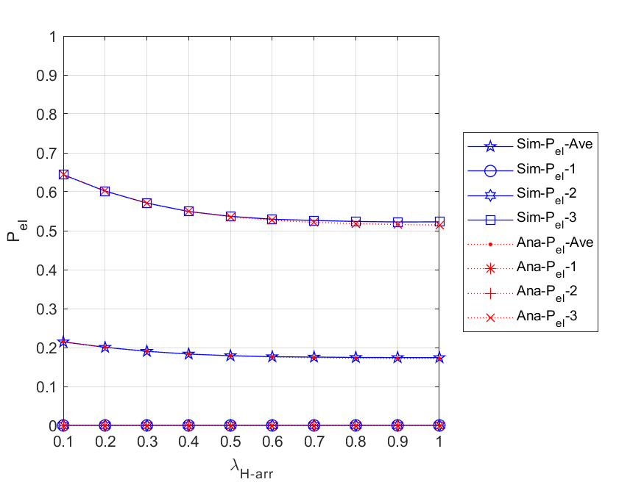

Fig. 5 - 49: The energy loss probabilities of the network and each node vs. the external HP packet arrival rate

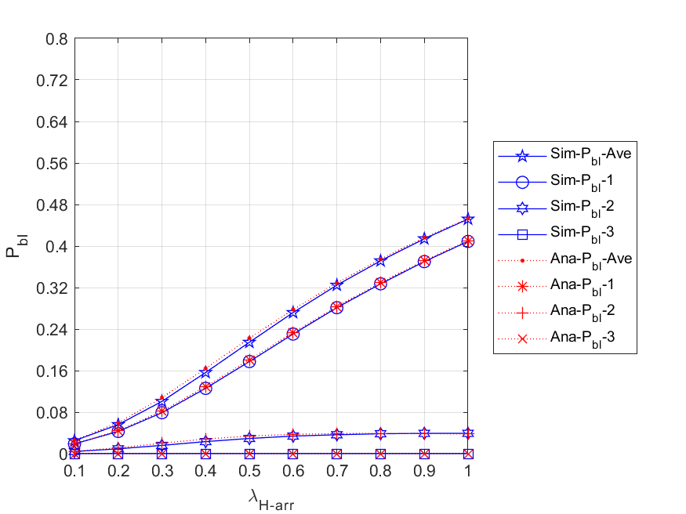

Fig. 5 - 50: The blocking probabilities for all arrived packets of the network and each node vs. the external HP packet arrival rate

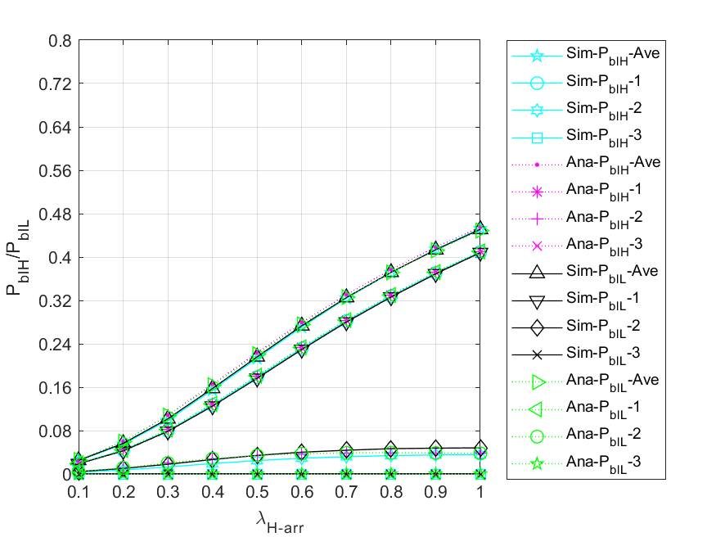

Fig. 5 - 51: The blocking probabilities for arrived HP and LP packets of the network and each node vs. the external HP packet arrival rate

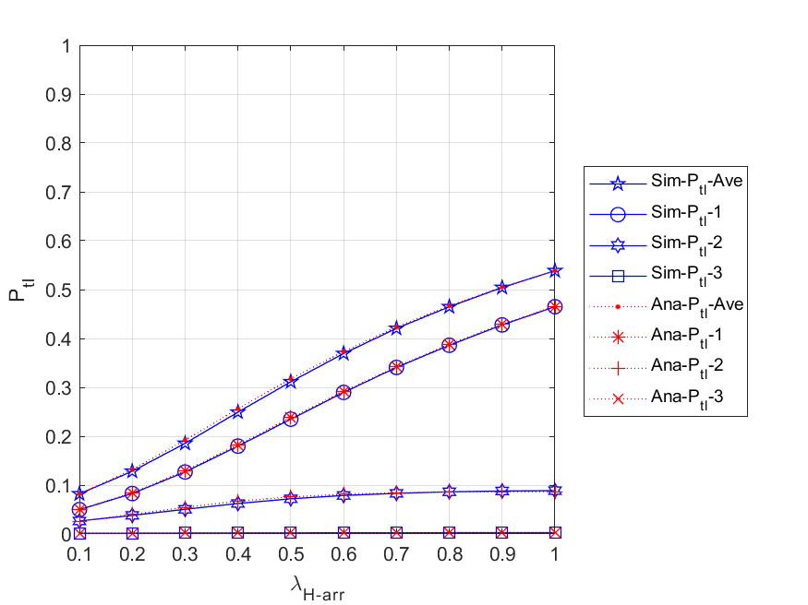

Fig. 5 - 52: The total loss probabilities for all arrived packets of the network and each node vs. the external HP packet arrival rate

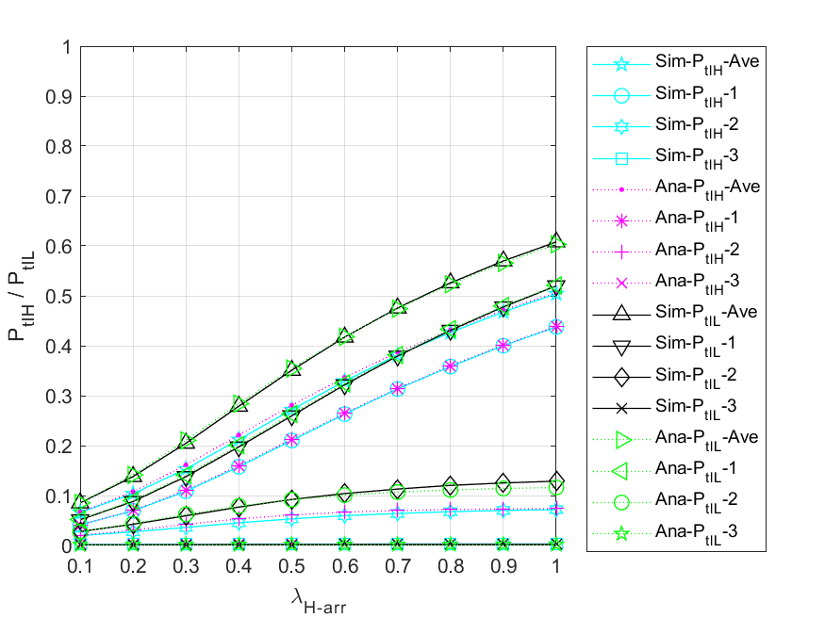

Fig. 5 - 53: The total loss probabilities for all arrived packets of the network and each node vs. the external HP packet arrival rate

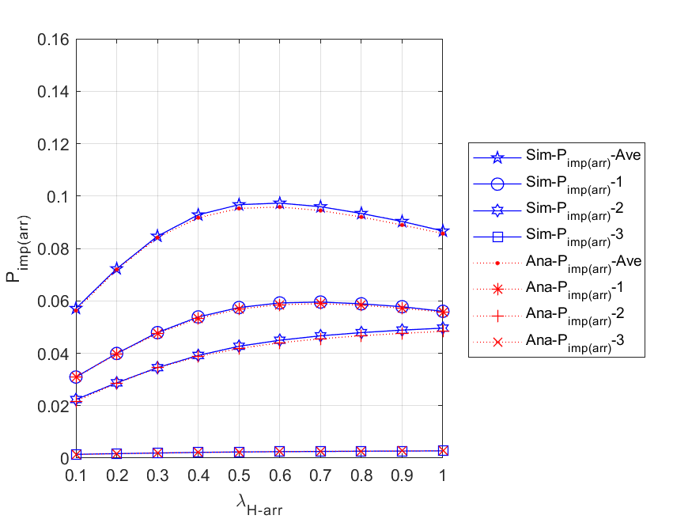

Fig. 5 - 54: The impatient loss probabilities for all arrived packets of the network and each node vs. the external HP packet arrival rate

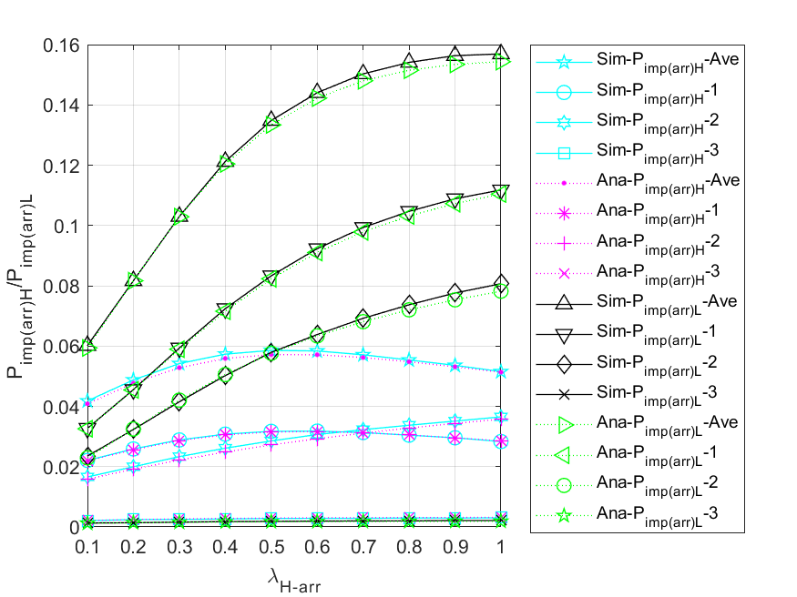

Fig. 5 - 55: The impatient loss probabilities for all arrived HP and LP packets of the network and each node vs. the external HP packet arrival rate

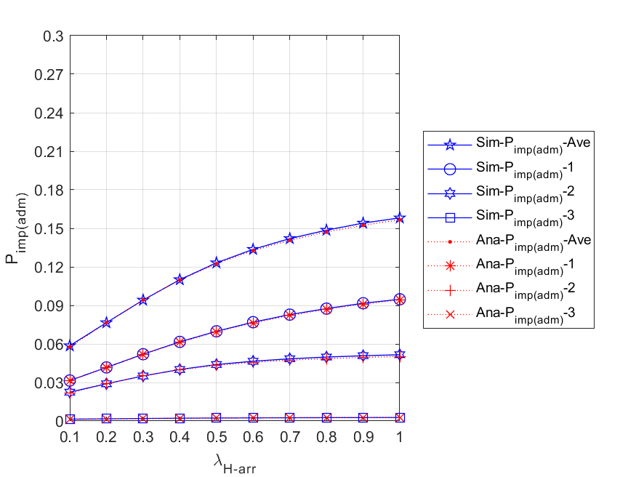

Fig. 5 - 56: The impatient loss probabilities for all admitted packets of the network and each node vs. the external HP packet arrival rate

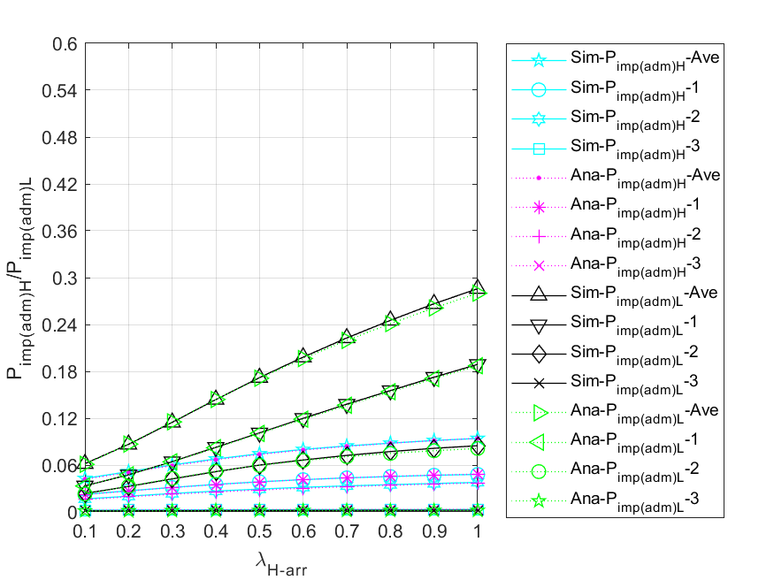

Fig. 5 - 57: The impatient loss probabilities for all admitted HP and LP packets of the network and each node vs. the external HP packet arrival rate

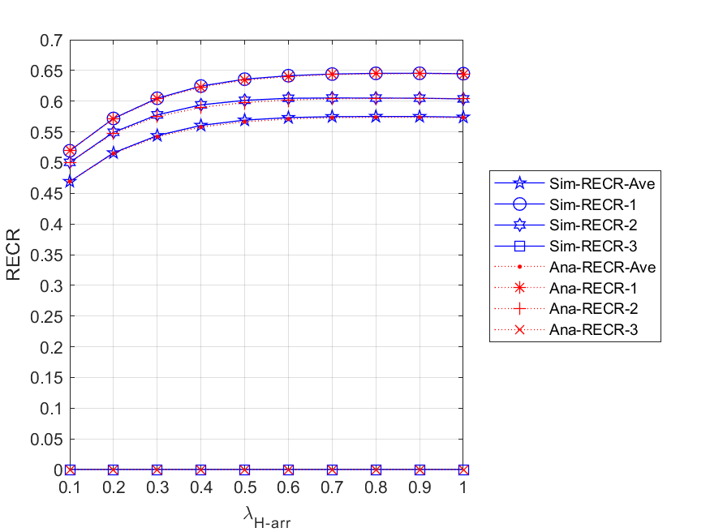

Fig. 5 - 58: The regular energy consumption ratio for serving all packets of the network and each node vs. the external HP packet arrival rate

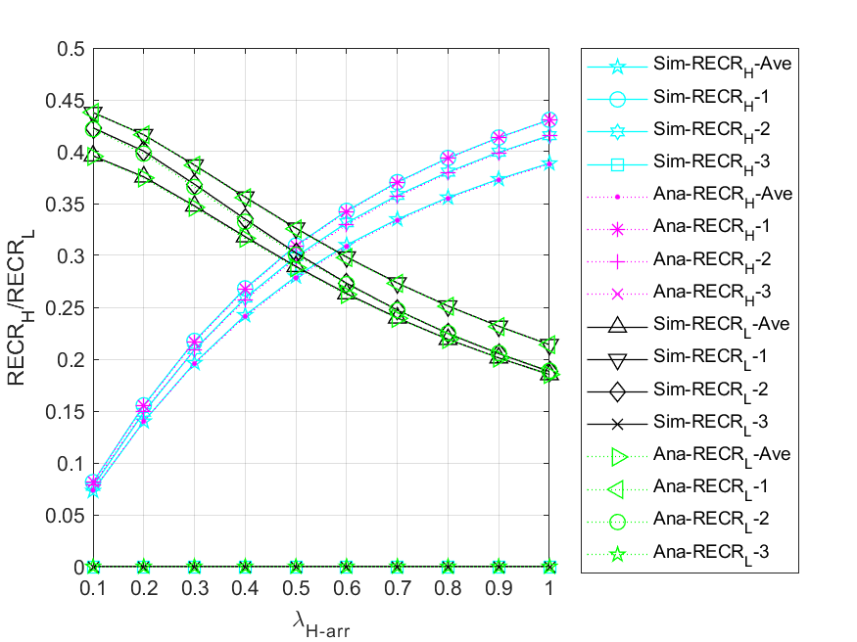

Fig. 5 - 59: The regular energy consumption ratio for serving HP and LP packets of the network and each node vs. the external HP packet arrival rate